ICP 4-Task2

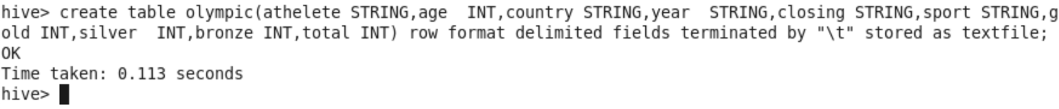  
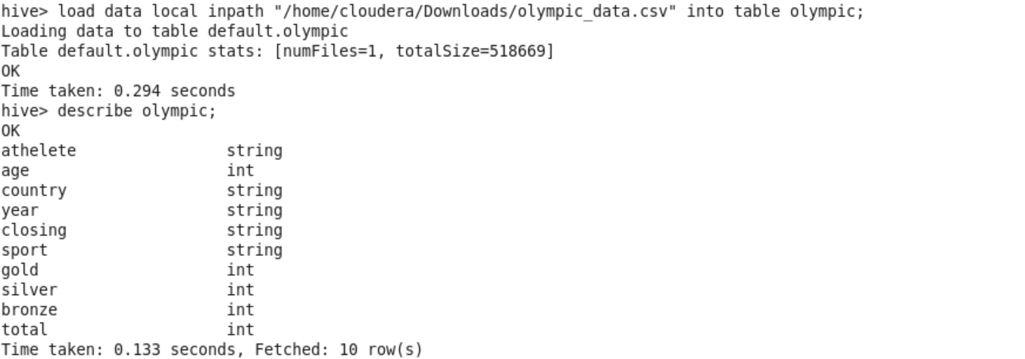

QUERY1:

Using the dataset list the total number of medals won by each country in

swimming.



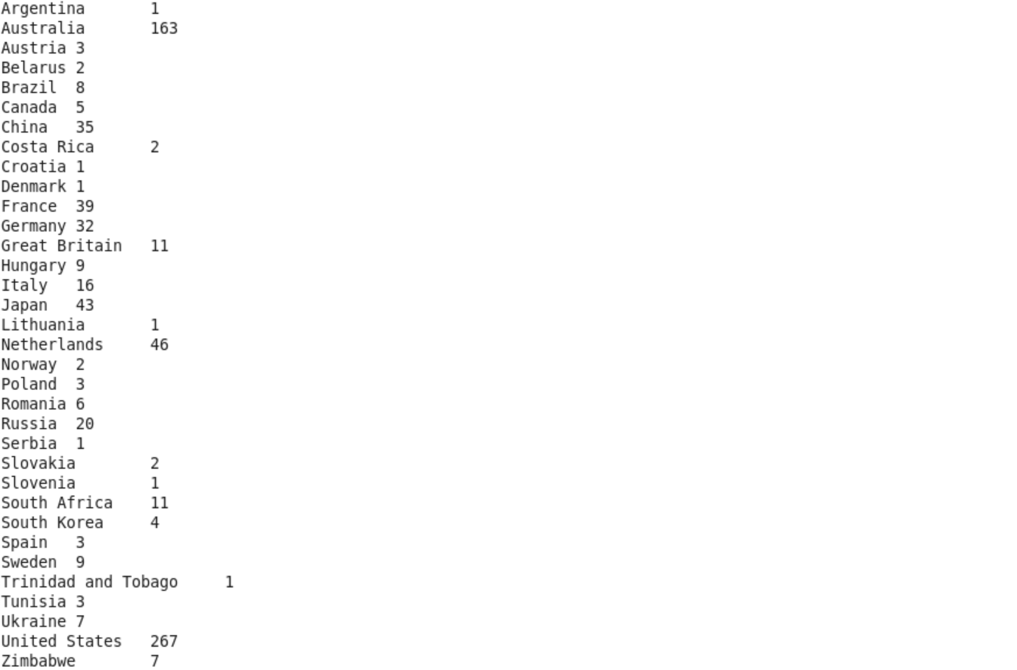

QUERY2:

Display real life number of medals India won year wise.

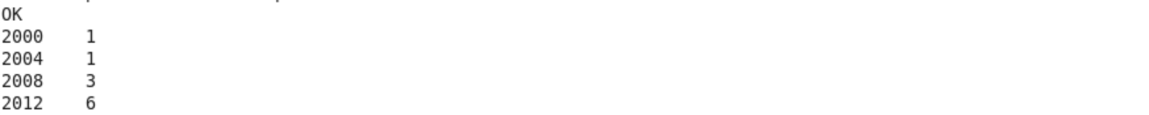

QUERY3:

Find the total number of medals each country won display the name along with

total medals.



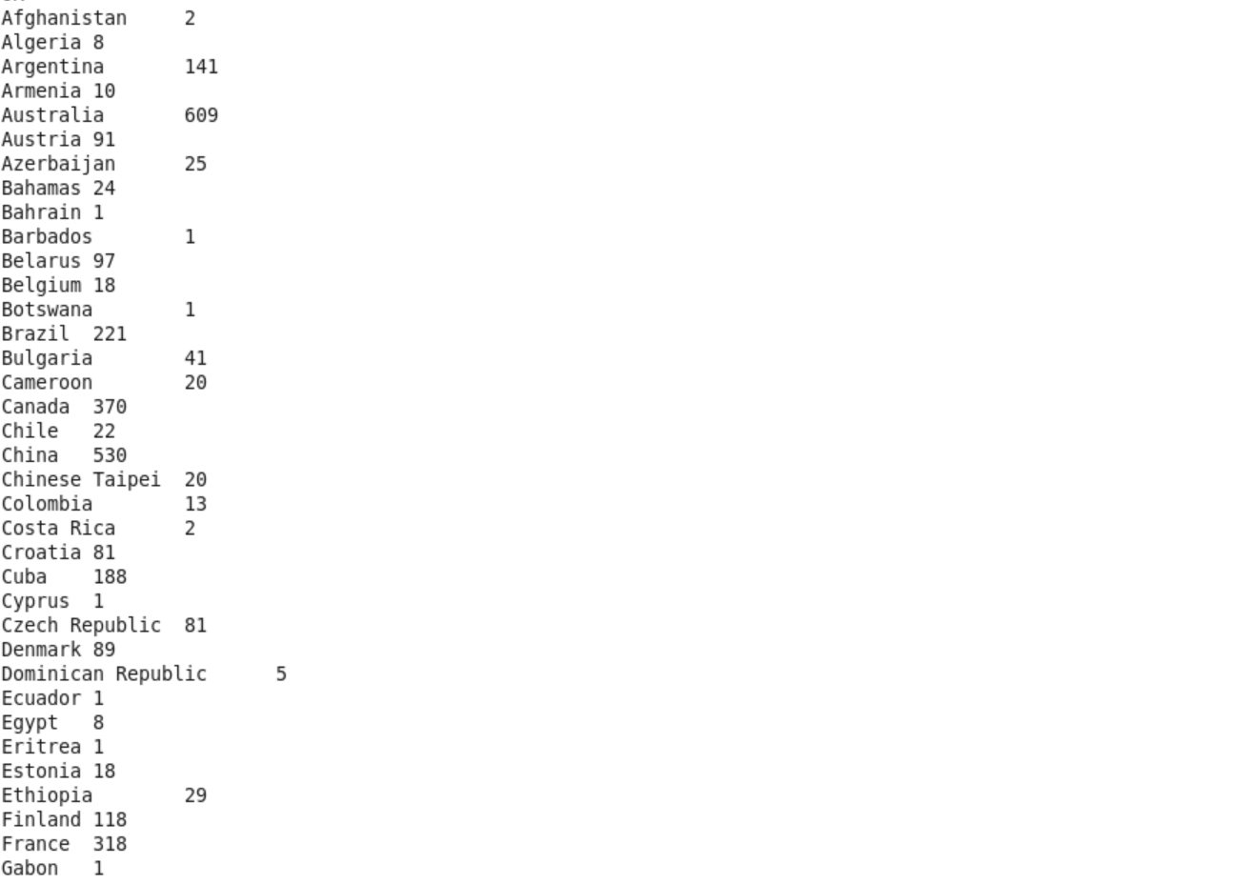

QUERY4:

Find the real life number of gold medals each country won.



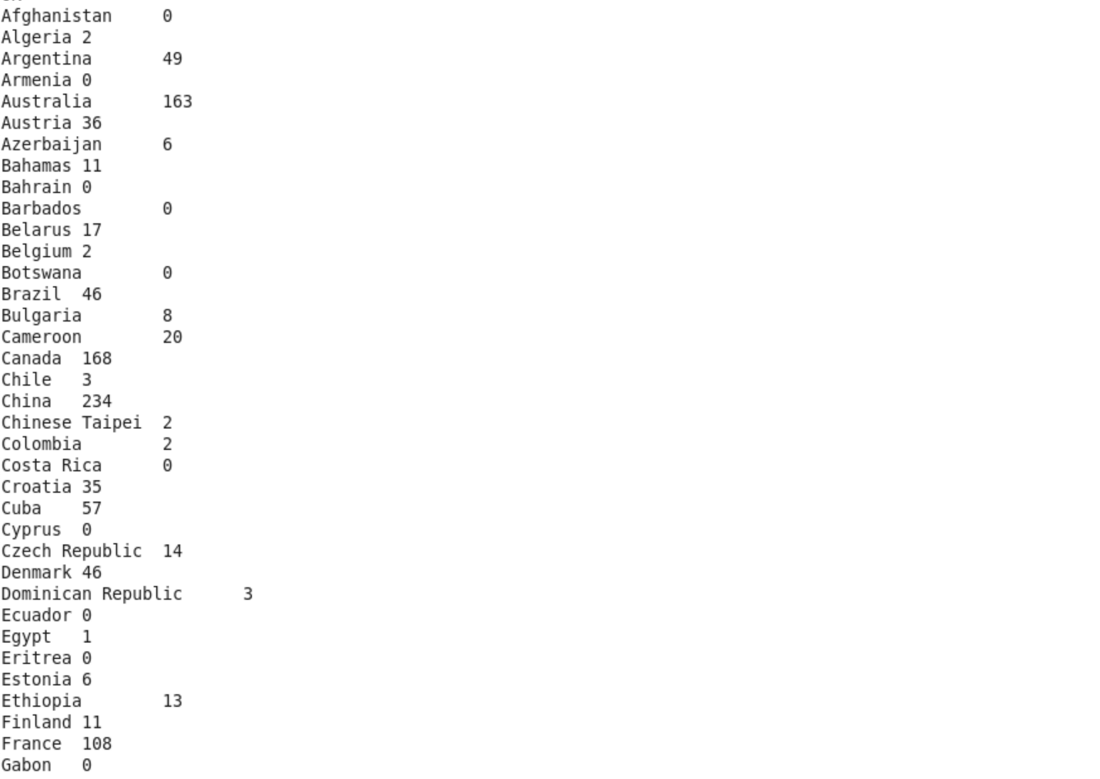

QUERY5:

Which country got medals for Shooting, year wise classification?



